**Property name:- Me:nam Homestay (Majuli)**

**Stay Type;- HomeStay**

**Max Capacity :- 30 Person**

**Price :- 3500rs**

**Location :-** [**https://www.google.com/maps/place/Me:nam+Homestay+(Majuli)/@27.0602567,94.2634877,19z/data=!4m6!3m5!1s0x3746d37af305cd35:0xdcb446aaa197a5d8!8m2!3d27.0602567!4d94.2639478!16s%2Fg%2F11k4rvzf23?hl=en&entry=ttu&g_ep=EgoyMDI0MTEwNi4wIKXMDSoASAFQAw%3D%3D**](https://www.google.com/maps/place/Me:nam+Homestay+(Majuli)/@27.0602567,94.2634877,19z/data=!4m6!3m5!1s0x3746d37af305cd35:0xdcb446aaa197a5d8!8m2!3d27.0602567!4d94.2639478!16s%2Fg%2F11k4rvzf23?hl=en&entry=ttu&g_ep=EgoyMDI0MTEwNi4wIKXMDSoASAFQAw%3D%3D)

**Address:- Jengrai Chapori Rd, Kesaikhua gaon, Moghua Chuk, Assam 785105**

**Amanites:-**

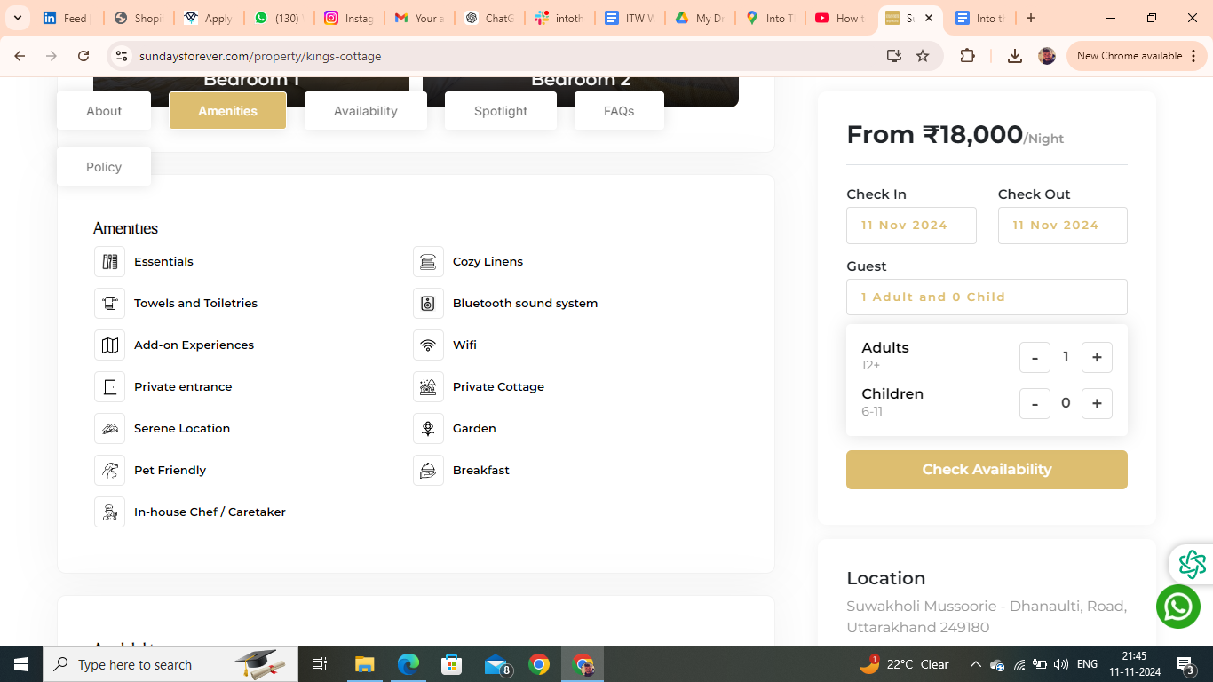

**Amanites you have to remove are :- Essentials, Bluetooth Sound System, Towel, Private entrance, Patio & balocny**

FAQs

**Is Driver and/or House-Help accommodation available?**

Driver accommodation depends upon the first come first serve basis. It is available at nominal charges a small room or Bunk bed with dinner and breakfast will be provided just nearby the property.

**Is parking available onsite or nearby?**

Free parking is available onsite. There is ample car parking for 4-5 cars at the site.

**Is the Property suitable for a day picnic?**

Yes, the home has a garden/lawn area within the premises that could be used for outdoor picnic activities. Meals will be provided on site at an additional charge (per person, per meal).

**Is property pet friendly?**

We’re happy to welcome your furry friends at Me:nam Homestay! Please bring a pet bed along, as pets aren’t allowed on guest beds or any linen. Enjoy a comfortable stay for you and your pet in the heart of nature!

**Booking Policies**

House rules

* Check-in: 2 PM Check-out: 10 AM
* Guest are requested to shut the windows and doors during the evening . as the property may be prone to insect and bug.
* Guest are not allowed to spill food or drinks over the upholstery or they will be charged at the time of checkout.
* Please Be mindful and keep the noise to the minimum after 10 pm.
* Passport, Aadhar, Driving License and Govt. ID are accepted as ID proof(s)
* Allows private parties or events

**Refund & Rescheduling Policy**

* Refund would be processed in 14 working days .
* Booking can be rescheduled till 15 days prior to arrival date depending upon the availability.
* Rs1000 plus applicable taxes will be charged for rescheduling .
* Rescheduling can be done only for the same property.
* If the tariff on the rescheduled date is higher than the initial booking date then the difference is payable.

**Things you need to know**

* The full payment must be made for your booking to be confirmed
* Only the guest who have been accounted for are allowed at the Property
* Any damage to the property caused by the guest will be charged as per the actual cost of repair or replacement.
* Any commercial activity is strictly not permitted.
* Guests are earnestly requested to treat the home with care.
* Any damage to the property caused by the guest will be charged as per the actual cost of repair or replacement.
* Consider this as a homestay in mountains not a Typical Hotel Stay

**Cancellation and Refund Policy**

* Cancellation 12 days prior to arrival date 15 % will be charged.
* Cancellation 07 days prior to arrival date 50 % will be charged.
* Cancellation less than a week full retention would be applicable.
* Credit/Debit card cancellation will be charged 5 % extra.
* Cancellation policy for long weekends and special days .
* Cancellation 07 days prior to arrival date 50 % will be charged .
* Cancellation less than a week full retention would be applicable.

**Description:-**

Welcome to Me:nam Homestay, nestled on Majuli Island, the world’s largest river island and a cultural treasure in Assam. Run by the owner herself, this homestay offers a warm, local touch, giving guests an unforgettable experience. From meeting locals to exploring traditional crafts and customs.

Me:nam Homestay is your gateway to the authentic heart of Majuli—an island rich in natural beauty, vibrant festivals, and deep-rooted traditions.

**Things to Do at Me:nam Homestay**

* **Boating**: Glide along the serene Brahmaputra River.
* **Mask Making**: Discover Majuli’s traditional art of handmade masks.
* **Pottery Village**: Visit local artisans crafting pottery by hand.
* **Apong Making**: Learn to make Apong, Assam’s unique rice beer.
* **Weaving**: Watch intricate weaving techniques by local craftsmen.
* **Village Walk**: Stroll through picturesque villages, meeting locals and experiencing daily life.